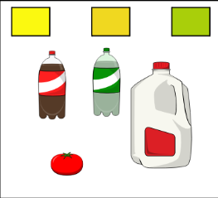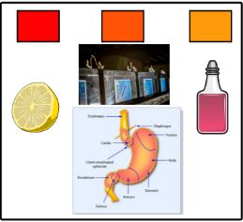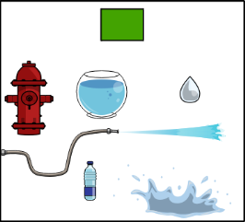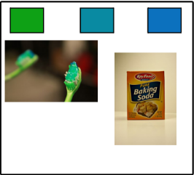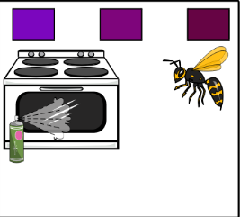

|  |  |  |  |  |
| --- | --- | --- | --- | --- |
| 1 | 2 | 3 | 4 | 5 |

|  |
| --- |
| C:\Users\fracesgar\Desktop\imagen ph.png |

Principio del formulario